

DERSİN ADI: Algoritma Analizi

DERSİN EĞİTMENİ: Dr. Öğr. Üyesi Mehmet Amaç GÜVENSAN

ÖĞRENCİ ADI: Ertuğrul ŞENTÜRK

ÖĞRENCİ NO: 18011028

ÖĞRENCİ MAIL: mdesenturk@gmail.com

DÖNEM: 3

GRUP NO: 2

ÖDEV NO: Proje

ÖDEV KONUSU: Kitap Öneri Sistemi

Algoritma:

1. Verilen dosyadaki veriler uygun şekilde okunup dosyaya kaydedildi.
2. Kullanıcıdan hesaplamada kullanılacak benzer kullanıcı sayısı alındı.
3. Verilen inputlar ile her nu üyesinin u üyesi ile pearson kaysayısı hesaplandı.
4. İstenilen benzer kullanıcı sayısı kadar maximum eleman dizinin başına taşındı ve indexleri k_max adından bir diziye kaydedildi.
5. Bu kullanıcıların benzerlik oranı hakkında bilgi yazdırıldı.
6. Sonrasında kullanıcıdan tek kullanıcıya ait mi yoksa tüm kullanıcıya ait mi öneri yapılacağının bilgisi alındı.
7. Alınan bilgiye göre seçilen nu kullanıcıların okumadığı kitaplar hakkında predicate fonksiyonu çağırılarak tahmin yapıldı.
8. Tahmin yapılan kitapların tahmin değerleri arasından maksimumu kullanıcı için önerilen kitap olacağından o kitabın bilgisi yazdırıldı.

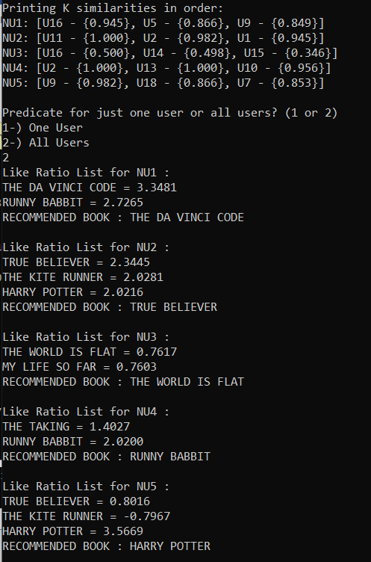Ekran görüntüleri:

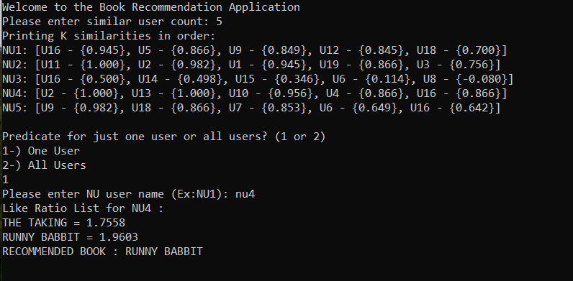

#include <stdio.h>

#include <stdlib.h>

#include <string.h>

#include <stdbool.h>

#include <math.h>

#include <float.h>

// Max available book count

#define MAX_BOOK_COUNT 50

// Max available book name

#define MAX_BOOK_NAME 200

// Max available user count

#define MAX_USER_COUNT 100

// Buffer size for a row

#define ROW_BUFFER 10

// Database file name

const static char data[] = "RecomendationDataSet.csv";

// Struct definition for keeping user info

// name = user name

// book_list = book ratings giving by the user

struct{

char name[ROW_BUFFER];

int* book_list;

}typedef user;

// Database reading functions

int read_book_names(FILE* database,char *** book_names);

int read_users(FILE* database, user users[], int book_count);

bool read_database(const char* file_name,FILE** database);

bool skip_line(FILE* database);

// Pearson calculation

float calculate_pearson(user u1, user u2, int book_count);

float* calculate_all_similarities(user nu_user,user* u_users,int u_count,int book_count);

// K max element calculation

int* find_kmax(int k, float* values, int size);

// Predication calculation for a book

float calculate_pred(user nu, int book_number, user u_users[],const int* kmax, int k,int book_count);

void predicate_user(user nu_user,int nu_order,user u_users[],int k,int** kmax_list,char** book_names,int book_count);

// Test function

int ** test1(int k, user nu_users[],int nu_count,user u_users[],int u_count,int book_count);

void test2and3(user nu_users[], int nu_count, user u_users[], int** kmax_list, int k, char** book_names,int book_count);

// Dellocation functions

void free_book_names(char** book_names);

void free_users(user users[],int u_count);

void free_kmax_list(int** kmax_list,int nu_count);

int main(){

// variable definitions

int k;

int book_count;

int u_count;

int nu_count;

char** book_names;

int** kmax_list;

user u_users[MAX_USER_COUNT];

user nu_users[MAX_USER_COUNT];

// reading database

FILE* database;

if (!read_database(data,&database))

return 0;

// initializing variables

book_count = read_book_names(database,&book_names);

u_count = read_users(database,u_users,book_count);

skip_line(database);

nu_count = read_users(database,nu_users,book_count);

fclose(database);

printf("Welcome to the Book Recommendation Application\n");

printf("Please enter similar user count: ");

scanf("%d",&k);

if (k>u_count || k<1){

printf("k value is invalid");

return 0;

}

// Starting test1 and generating kmax_list

kmax_list = test1(k,nu_users,nu_count,u_users,u_count,book_count);

// Starting test2 and test 3

test2and3(nu_users, nu_count, u_users, kmax_list, k, book_names, book_count);

// memory is freed to recover from memory leak

free_book_names(book_names);

free_users(u_users, u_count);

free_users(nu_users, nu_count);

free_kmax_list(kmax_list,nu_count);

return 0;

}

/* Book name reading function

param:

database = file pointer to read database from file

book_names == array which is keeps book names;

var:

i = iterator;

book_count = count of books;

buff = buffer to keep a row content;

c = temporary char for reading character

return:

book_count = count of books;

*/

int read_book_names(FILE* database,char *** book_names){

int i;

int book_count;

char buff[MAX_BOOK_NAME];

char c;

// allocate memory for book list

*book_names = (char**) malloc(sizeof(char*) * MAX_BOOK_COUNT);

for(i = 0; i < MAX_BOOK_COUNT; i++){

// allocate memory for each book

(*book_names)[i] = (char*) malloc(sizeof(char) * MAX_BOOK_NAME);

}

// Remove first , for first empty

c = fgetc(database);

i = 0;

book_count = 0;

while(c != '\n' && c != EOF){

c = fgetc(database);

if(c!=','){

// Add characters to buffer

buff[i] = c;

i++;

}

else{

// Add endl at the end of the buffer for stoping buffer

buff[i] = '\0';

// Copy buffer to array

strncpy((*book_names)[book_count],buff,i+1);

// Increase book count

book_count++;

// Start buff from begining

i = 0;

}

}

// Add last cell.

buff[i-1] = '\0';

strncpy((*book_names)[book_count], buff, i+1);

// Return book count

return book_count+1;

}

/* User reading function

param:

database = file pointer to read database from file

users == array which is users;

book_count = count of books;

var:

i,j,k = iterator;

buff = buffer to keep a row content;

c = temporary char for reading character

temp = keeps integer value of a row

return:

user count;

*/

int read_users(FILE* database, user users[], int book_count){

int i, j, k;

char buff[ROW_BUFFER];

char c;

int temp;

// Read first char

c = fgetc(database);

i = 0;

// If first char is , that means first cell is empty

while(c!=',' && c!=EOF){

// Set values for new user

users[i].book_list = (int*) malloc(sizeof(int)*book_count);

j = 0;

// Read until end of the line

while (c!='\n' && c != EOF){

k=0;

// Read a cell

while(c != ',' && c != '\n' && c != EOF){

buff[k] = c;

c = fgetc(database);

k++;

}

// For end of the cells

if(c != '\n'){

// Copt last cell

buff[k] = '\0';

// For first cell read username

if(j == 0){

strcpy(users[i].name, buff);

}

// For other cells convert value to integer and add it into book list

else{

temp = atoi(buff);

users[i].book_list[j-1] = temp;

}

c = fgetc(database);

// Clear buffer for end of the line

if(c == '\n')

buff[0] = '\0';

}

j++;

}

// Add last cell

temp = atoi(buff);

if(temp != 0){

j--;

}

users[i].book_list[j-1] = temp;

while(c == '\n')

c = fgetc(database);

i++;

}

// Return user count

return i;

}

/* File reading function

param:

file_name = file location for reading

database = file pointer to read database from file;

return:

success of reading

*/

bool read_database(const char* file_name,FILE** database){

*database = fopen(file_name,"r");

if(!*database){

printf("File not found\n");

return false;

}

return true;

}

/* File reading function

param:

database = file pointer to read database from file;

var:

c = temporary char for reading character

return:

success of reading

*/

bool skip_line(FILE* database){

char c = '.';

while(c != '\n')

c = fgetc(database);

}

/* Pearson coefficent calculation function

param:

u1 = first user

u2 = second user

book_count = book count;

var:

i = iterator

numerator = top of the division

denominator1, denominator2 = botton of the division

average1, average2 = average values

common_book = book count readed by both user

return:

pearson coefficent

*/

float calculate_pearson(user u1, user u2, int book_count){

int i;

float numerator = 0;

float denominator1 = 0;

float denominator2 = 0;

float average1 = 0;

float average2 = 0;

int common_book = 0;

//Calculate sum value for books both readed

for(i=0;i<book_count;i++){

// Only calculate if both user readed same book

if(u1.book_list[i]>0 && u2.book_list[i]>0){

average1+=u1.book_list[i];

average2+=u2.book_list[i];

common_book++;

}

}

// Calculate average by dividing common book count

average1 /= (float)common_book;

average2 /= (float)common_book;

for(i=0;i<book_count;i++){

// Only calculate if both user readed same book

if(u1.book_list[i]>0 && u2.book_list[i]>0){

numerator += ((float)u1.book_list[i] - average1) * ((float)u2.book_list[i] - average2);

denominator1 += pow(((float)u1.book_list[i] - average1), 2);

denominator2 += pow(((float)u2.book_list[i] - average2), 2);

}

}

// calculate result

return numerator / (sqrt(denominator1) * sqrt(denominator2));

}

/* Pearson coefficent array generator for a nu user

param:

nu_user = nu user, u_users = u user list , u_count = u user count , book_count = book count;

var:

i = iterator , pearson_values = list of pearson values for a nu user

return:

list of pearson values for a nu user*/

float* calculate_all_similarities(user nu_user,user* u_users,int u_count,int book_count){

int i;

float* pearson_values = (float*) malloc(sizeof(float)*u_count);

for(i=0;i<u_count;i++){

pearson_values[i] = calculate_pearson(nu_user,u_users[i],book_count);

}

return pearson_values;

}

/* Calculates first k maxiumum

param:

k = similar user count

values = pearson values for a nu user

size = u user count

var:

i,j = iterator

t,temp = temp values

kmax = array to keeps k max users index;

return:

array to keeps k max users index

*/

int* find_kmax(int k, float* values, int size){

int i,j;

int t;

float temp;

int* kmax = (int*) malloc(sizeof(int)*size);

for(i=0;i<size;i++){

kmax[i] = i;

}

for(i=0;i<k;i++){

for(j=i+1;j<size;j++){

// swap index array and value array partial bubble sort with k step

if(values[i]<values[j]){

temp = values[i];

values[i] = values[j];

values[j] = temp;

t = kmax[i];

kmax[i] = kmax[j];

kmax[j] = t;

}

}

}

return kmax;

}

/* Calculation of predication value for a book from first k user

param:

nu = nu user to generate recommendation

book_number = book order for predication

kmax = k max u user's index

k = similar user count

book_count = count of all books

var:

i = iterator

numerator = top part of division

denominator = botton part of division

similarity = keeps pearson value between u user and nu user

user u = temp value for keeping each u user

u_average = average value for u_users;

nu_average = average value for nu_user;

read_count = temporary value for readed book count for any user;

return:

predication value for selected book and nu user

*/

float calculate_pred(user nu, int book_number, user u_users[],const int* kmax, int k,int book_count){

int i,j;

float numerator = 0;

float denominator = 0;

float similarity;

user u;

float u_average;

float nu_average = 0;

int read_count = 0;

for(i = 0;i<book_count;i++){

if(nu.book_list[i]!=0){

read_count++;

nu_average += (float)nu.book_list[i];

}

}

nu_average /= (float) read_count;

for(i = 0; i < k; i++){

u = u_users[kmax[i]];

u_average = 0;

read_count = 0;

for(j = 0; j<book_count; j++){

if(u.book_list[j]!=0){

u_average += (float)u.book_list[j];

read_count++;

}

}

u_average /= (float) read_count;

similarity = calculate_pearson(nu,u,book_count);

numerator += similarity*((float)u.book_list[book_number]-u_average);

denominator += similarity;

}

return nu_average + (numerator/denominator);

}/* Makes predication for one nu user

param:

nu_user = nu user to generate recommendation, nu_order = order no to user

u_users = u user array

k = similar user count, kmax_list = k max index array

book_names = all book names

book_count = count of all books

var:

i = iterator

pred = predication value for each unreaded book

denominator = botton part of division

max_index = keeps index of max predication

max_value = keeps value of max predication

*/

void predicate_user(user nu_user,int nu_order,user u_users[],int k,int** kmax_list,char** book_names,int book_count){

int i;

float pred;

int max_index = 0;

float max_value=FLT_MIN;

printf("Like Ratio List for %s : \n",nu_user.name);

for(i=0;i<book_count;i++){

// If NU user not readed that book yet

if(nu_user.book_list[i] == 0){

// Calculate each non readed book predication

pred = calculate_pred(nu_user,i,u_users,kmax_list[nu_order],k,book_count);

// Print the values and book names

printf("%s = %0.4f\n",book_names[i],pred);

// Keep track of maximum

if(max_value<pred){

max_value = pred;

max_index = i;

}

}

}

// Print maximum as a recommended book

printf("RECOMMENDED BOOK : %s\n\n",book_names[max_index]);

}

/* Calculation of predication value for a book from first k user

param:

k = similar user count

nu_users = nu user array to generate recommendation

nu_count = nu user count

u_users = u user array for predication

u_count = u user count

book_count = count of all books

var:

i,j = iterator

kmax_list = k max index array value for selected book and nu user

similarities = array of similartiy values for a nu user;

similaritiy_list = array of similarties values for each nu user;

return:

kmax_list = k max index array value for selected book and nu user

*/

int ** test1(int k, user nu_users[],int nu_count,user u_users[],int u_count,int book_count){

int i,j;

// Memory allocation for calculating arrays

int ** kmax_list = (int**) malloc(sizeof(int*)*nu_count);

float* similarities;

float** similaritiy_list = (float**) malloc(sizeof(float*)*nu_count);

// For each nu user

for(i = 0;i<nu_count;i++){

// Calculate similarity values for each u user

similarities = calculate_all_similarities(nu_users[i],u_users,u_count,book_count);

// Find k max;

kmax_list[i] = find_kmax(k,similarities,u_count);

// Generate similarity array for printing

similaritiy_list[i] = similarities;

}

// Print similarity values and deallocate arrays

printf("Printing K similarities in order:\n");

for(i=0;i<nu_count;i++){

printf("NU%d: [",i+1);

for(j=0;j<k-1;j++){

printf("U%d - {%0.3f}, ",kmax_list[i][j]+1,similaritiy_list[i][j]);

}

printf("U%d - {%0.3f}]\n",kmax_list[i][j]+1,similaritiy_list[i][j]);

free(similaritiy_list[i]);

}

free(similaritiy_list);

printf("\n");

// Return k min list

return kmax_list;

}/* Calculation of predication value for a book from first k user

param:

nu_users = nu user array to generate recommendation

nu_count = nu user count

u_users = u user array for predication

kmax_list = k max index array value for selected book and nu user

k = similar user count, book_names = names of all books

book_count = count of all books

var:

i = iterator

choice = print option - input from user

user_name = user name - input from user

*/

void test2and3(user nu_users[], int nu_count, user u_users[], int** kmax_list, int k, char** book_names,int book_count){

int i;

char choice;

char user_name[ROW_BUFFER];

// Get input for print one selected user's result or all users result

printf("Predicate for just one user or all users? (1 or 2)\n1-) One User\n2-) All Users\n");

scanf(" %c",&choice);

// Print all user

if(choice == '2'){

for(i=0;i<nu_count;i++){

predicate_user(nu_users[i],i,u_users,k,kmax_list,book_names,book_count);

}

return;

}

else{

// Get user name

printf("Please enter NU user name (Ex:NU1): ");

scanf("%s",user_name);

// Find user index

i=0;

while(i<nu_count && strcasecmp(user_name,nu_users[i].name) != 0)

i++;

// If user exist call predicate for that user

if(i== nu_count)

printf("User not found");

else

predicate_user(nu_users[i],i,u_users,k,kmax_list,book_names,book_count);

}

}/* Memory deallocation for book names

param:

book_names = array of book names

var:

i = iterator

*/

void free_book_names(char** book_names){

int i;

for(i=0;i<MAX_BOOK_COUNT;i++){

free(book_names[i]);

}

free(book_names);

}

/* Memory deallocation for user array

param: users = user array , u_count = array size

var: i = iterator

*/

void free_users(user users[],int u_count){

int i;

for(i=0;i<u_count;i++){

free(users[i].book_list);

}

}

/* Memory deallocation for k mix list array

param: kmax_list = k mix list array , nu_count = array size

var: i = iterator

*/

void free_kmax_list(int** kmax_list,int nu_count){

int i;

for(i=0;i<nu_count;i++){

free(kmax_list[i]);

}

free(kmax_list);

}